# MacBook Trackpad Not Clicking (How to Fix)

Be it accessing your files, browsing the net, using your Mac for entertaining purposes, or carrying out any simple routine tasks, you cannot use your system without the trackpad. You can use an External Mouse sometimes, but no one likes to resort to it. Besides, using key combinations cannot entirely replace the trackpad function, nor will it make your work easier even if you are a tech freak. It is annoying when you want to use your device, and the trackpad does not work. Mac users often face the issue. So, if you are struggling with MacBook Trackpad Not Clicking (How to Fix), we have covered you all.

It might be that your trackpad has dirt and grime, and in that case, you should clean it up with a dry or lint-free cloth. Other recent app installations, not installing upgrades, and improperly setup settings also account for the issue.

## How to Fix MacBook Trackpad Not Working?

Several reasons account for MacBook Trackpad Not Working. All of the factors vary as per your usage and device configurations. Depending on them, you can fix MacBook Trackpad Not Working by the following methods!

### Method 1: Connect an External Mouse

Connecting an external mouse is the simplest way not to let your chores suffer. When you are all piled up, you cannot afford to lose time fixing the trackpad. So, connect an external mouse until you resolve the trackball not clicking issue.

### Method 2: Disable Force Click

You might not often, but often Force Click is enabled on your MacBook. When it is enabled, you must press the trackpad rigidly to detect a touch. Thus, normal clicks would not be registered on your device if it is turned on.

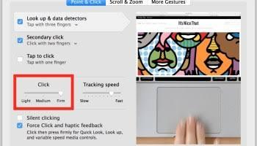

Follow the steps given below to disable Force Click on MacBook:

* In the menu of your Mac, press the Apple Logo
* Go to System Preferences
* Click on Trackpad
* Navigate to Point and Click Tab
* Toggle off the Force Click and Haptic Feedback option

However, if Force Click is not enabled, the System Preferences settings would be improperly configured. You have to check it.

### Method 3: Check System Preferences

Several options in System Preferences tend to mess up your Trackball functioning and thus lead to the issue. So, you can browse through the System Preferences to check if any option is improperly configured or not.

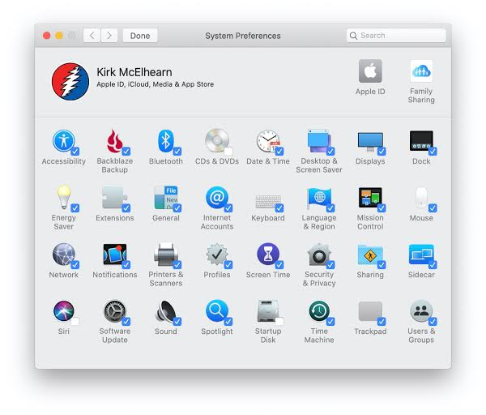

### Method 4: Reset Factory Settings for Trackpad

You would personalize your Mac to get the best user experience with your prerequisites. Often any such trackpad settings would lead to the issue. To resolve them, you can reset Trackpad Settings to default. Many users reported that it had fixed their Trackpad not working issue.

Follow the steps given below to reset trackpad settings to default:

* Head over to System Preferences
* Go to the Trackpad option
* Uncheck the "Tap to Click" and Scroll Direction Settings checkbox to reset the trackpad settings to default.

If that does not work, nothing is wrong with your Trackball Settings so that you can reset the Non Volatile Random Access Memory or Parameter Random Access Memory.

### Method 5: Reset NVRAM OR PRAM

If you are a knack for technical stuff, you would often reset NVRAM or PRAM on your Mac to resolve any errors.

However, if you have not, follow the steps below to reset it on your MAC!

* Turn off your MacBook
* Afterward, press the power button to turn in on
* While doing so, press Command+P+R keys simultaneously for up to 20 seconds to boot your device

The moment you hear three chimes, it indicates that your NVRAM or PRAM has reset to default.

### Method 6: Reset the SMC

Another hack you can use is to reset the System Management Controller or SMC to resolve several problems on your Mac, including the Trackpad not working. The method to reset SMC differs as per how old your Mac is.

#### Reset the SMC in MacBooks Older than 2017

* Turn off your Mac
* Press the Shift+Control+Option+power button simultaneously until 10 seconds
* Afterward, use the Power key to turn on your system

#### Reset SMC in Mac models after 2018

* Unplug your Mac from the socket
* Please wait for 15 seconds and then plug it into the socket
* Wait for 5 seconds
* Afterward, reboot your MacBook, and SMC will be reset.

### Method 7: Run Apple Diagnostics

MacBook has an inbuilt Diagnostics tool that detects problems, and you can then fix them.

Follow the steps given below to run the Apple Diagnostics tool:

* Hold the power button to turn off Mac
* Immediately press the D key from the keyboard, and it will boot
* The moment you see a dialog box asking you to choose a language, release the D key
* Choose the language and press the OK button

Apple Diagnostics tool will now run and detect your system. You will further be prompted to fix the issue that it detects. Additionally, you should delete the plist files for your system to run optimally.

### Method 8: Delete Preference Files having Plist Extension

Preferences files are present on every system. With time, these preference files get corrupted due to XYZ reasons, resulting in several error messages.

Deleting the plist files will also fix the Trackpad not clicking issue.

Follow the steps given below to do so:

* Head over to Finder
* Navigate to the Go To Folder
* Search for

~/Library/Preferences

And click on the first option that pops up

* Locate the *"com.apple.systempreferences.plist"* file and proceed to delete it

Alternatively, an outdated Macintosh Operating System can also result in it!

### Method 9: Update macOS

Every device receives frequent updates. When you follow them up timely, you get rid of unprecedented errors on your device. Similarly, for your MacBook to perform optimally, you should update it. Check for any updates and download them.

### Method 10: Reinstall Macintosh OS with Recovery

Macs work on the Macintosh Operating System. In case of bugs, reinstalling Macintosh with Recovery Mode helps eliminate glitches and will help you get rid of the Trackball error.

Follow the steps given below to reinstall macOS in Recovery Mode:

* Switch off your MacBook and press its power button
* At the instant, press the Command+R keys simultaneously
* As soon as the Apple logo appears, release the keys
* You might be prompted to enter the password if any
* The Recovery Mode menu pops up
* In it, navigate to Reinstall macOS

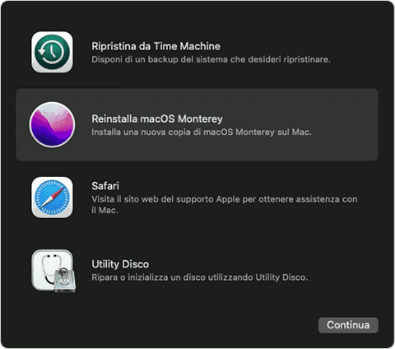

All the methods mentioned above will help you eliminate the problem. However, if somehow it does not work, then there is something fishy with your Mac's Hard Disk.

### Method 11: Format your Hard Disk

Before proceeding with this method, you must know that it will clear all your data. Further, as necessary, you should backup your data to a Cloud Drive and then erase the data on Hard Disk by formatting it!

Follow the steps given below to format your Hard Disk to solve the Trackpad not clicking problem:

* Turn off your Mac
* Now, press the Power button to boot it up
* Immediately press and hold the Command+R buttons simultaneously
* Apple logo appears on your screen, then release the keys
* The Apple Recovery Mode appears; head over to Disk Utility in it
* Click on Macintosh HD system drive
* Head over to the Erase option
* You will be asked about the Format Option. Select APFS or Mac Extended and click on it

After your hard disk is formatted, you can then reinstall your MacOS.

Your Trackpad Not Working problem will now be resolved.

## The Final Word

If you were looking out answers for the MacBook trackpad and not clicking (How to fix), then you have got your answer. You can connect an external mouse, disable Force Click, check for system preferences, and reset trackpad settings/NVRAM/SMC. Otherwise, you should reinstall the macOS or format the hard disk. If you have any queries, please let us know in the comments section below!

## Frequently Asked Questions

**Q.1.** Is the MacBook Trackpad Glass?

**A.1.** The trackpad of the MacBook is made up of glass so you can clean it easily. However, it helps only if you use an external trackpad, not an inbuilt one.

**Q.2.** Does the MacBook trackpad wear out?

**A.2.** No, the MacBook trackpad has a glass coating around. It does not wear out with advanced technology, design, and precision.

**Meta:** Are you facing the MacBook not clicking (How to fix)? If yes, click here to check out now!